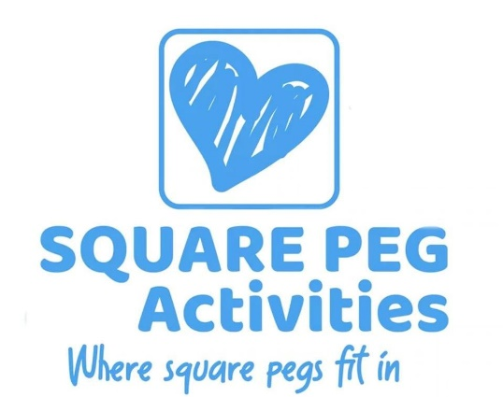

ANNUAL REPORT 2021
The Trustees present their Annual Report together with the financial statement for the year ended 31st August 2021. The Trustees have adopted the provisions of the statement of recommended practice.

STRUCTURE, GOVERNMENT & MANAGEMENT
Governing Document
The charity is controlled by its governing document, a deed of trust and constitutes a limited company, limited by guarantee as defined by the Companies Act 2006.

(SORP) Accounting and Reporting by Charities issued in 2005 in preparing the annual report and financial statement of the charity.

ABOUT US

Our mission and vision

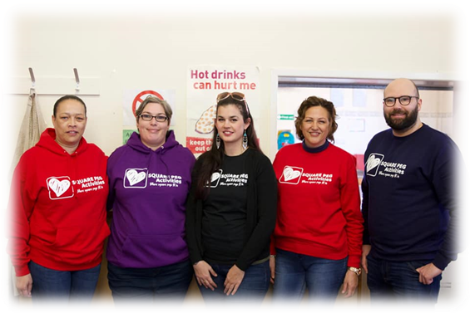
To address the social isolation felt by families affected by disability we need to offer fun enjoyable appropriate leisure activities which they can participate in as a family. For this to happen we liaise with a variety of organisations including schools, statutory organisations such as The Children’s Trust, CAT, (Communication and Autism Team) Family Support Workers and Social Workers. Our purpose is to provide appropriate leisure activities for disabled children of all ages by offering a range of activities, both in house and trips in the wider community to increase social interaction, allow children and parents to make friends, increase confidence and ultimately give children opportunities that they may not get otherwise. In the past 12 months we have also developed a new Advocacy Service to support parent/cares in a range of issues. The dedicated space and time allows a more structured approach giving the best possible support.

Why we do what we do?
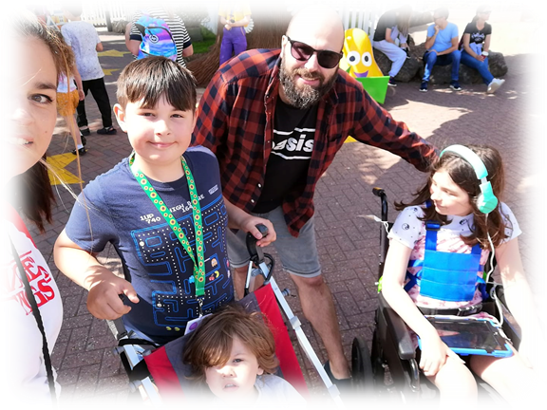
All children deserve to have fun, some need adjustments to allow then to be able to fully participate. Families are more likely to access services where activities have been tailored to their child’s disability than trying to make mainstream activities fit. Our message to families who haven’t yet tried us, is to come and have a go. The families who access our services have given us fantastic feedback which is why we do what we do.

PARENT VIEWS
CLARE
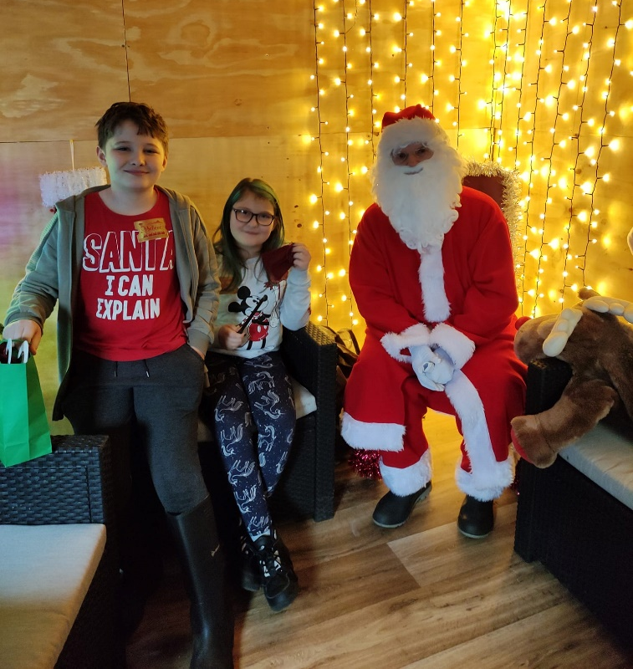
We as a family have been involved with Square Peg for a number of years. Firstly, we only attended set events such as Sensory Santa, Wizard School and day trips. Once Square Peg settled into their Gate Lane premises, we have found it much easier to engage.
G (aged 10 with ASD and ADHD) struggles with large spaces, noises and masses of other children so it’s far easier having a home from home space. Square Peg and its staff have made a huge difference to us as a family having groups and activities we can afford, and it feels safe. It is unique.
Both the children and I have made friends (not easy) and enjoy all the activities offered especially the Home Education Club and holiday activities.
We feel listened to, valued and wanted and that’s almost impossible to find elsewhere.

PAULINE
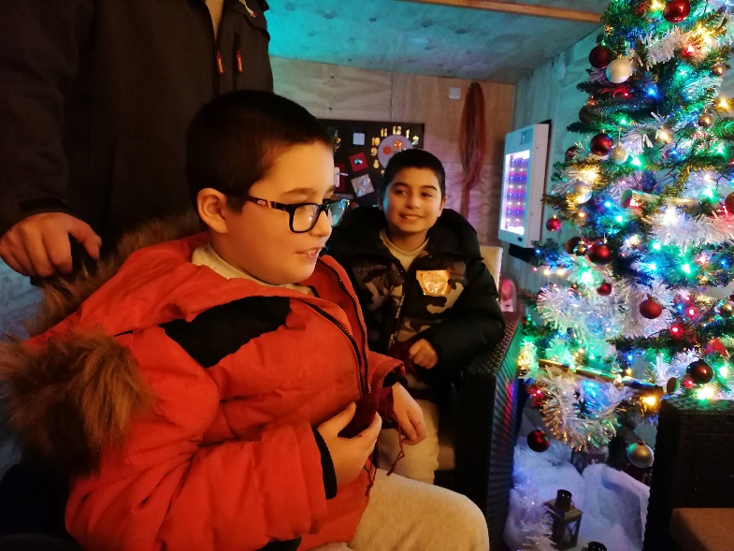
My partner and I have been going to Square Peg activities for about 4 years. My partner has 2 boys K aged 10 is diagnosed with Global development delay and is currently being assessed for ASD and has selective mutism. R aged 9 had a stroke at birth and is in a wheelchair and is also diagnosed with Global development delay.
I also have two boys S is 14 and has a diagnosis of ASD and high anxiety. A is 8 and is currently being assessed for ADHD. Attending Square Peg Activities has helped all the boys with their social and communication skills which has helped them to make new friends. It has been great seeing their confidence grow in the groups this is helped by the fact there are other children with additional needs and no one feels different or judged. It has also helped that siblings can attend. A loves going and has made many friends while attending Square Peg. K struggles with social and communication the most and struggles leaving his dad’s side but with Square Peg he has started feeling more confident playing and talking to others.
It has been good for us as parents as we feel relaxed as we know we won’t be judged by other parents. Its great talking to other parents and giving each other advice or encouragement.
Square peg has helped me with my son S on numerous occasions concerning his mental health and his education at mainstream school. They have signposted me to contacts as well as attending meetings with his school. I can contact members of Square Peg if I need advice or information which is a great help as I don’t think there is enough information available elsewhere. All staff are great with the children especially the staff from the summer activities the boys had so much fun.

VOLUNTEER VOICE

M.
I’ve been working as a volunteer playworker with Square Peg Activities since May 2021. Square Peg creates a wonderfully nurturing environment for children with a wide range of disabilities and neurodiverse differences and I have found it to be an inclusive, supportive and welcoming place for parents, children, volunteers and staff alike.
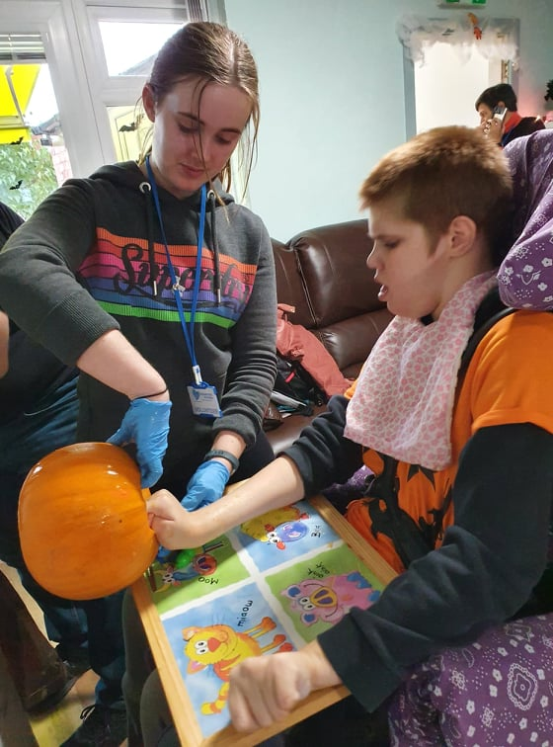
Through my volunteering at Square Peg, I’ve learnt how to adapt activities to the different needs of each child and this ethos of accessibility for everyone is at the heart of everything that Square Peg do. Whether it is supporting a child to get involved with a particular activity in a way that suits them best or recognising that some children will be happier simply watching or doing something else, the individual needs of each child are always considered and supported.
I have also learnt how challenging life can be for the parents of children with additional needs and supporting these parents is another priority for Square Peg. The activity sessions run at Square Peg offer an open and tolerant place where parents can bring their children without fear of being judged. While the Square Peg staff and volunteers occupy and support the children, parents can enjoy a short period of respite from what are often very challenging circumstances. At the same time, the centre offers a safe space where parents can talk to one another and share advice, guidance and experiences – which is also one of the many ways that Square Peg Activities enriches the lives of everyone that walks through their doors.

Note from CEO
This year has once again gone past in a blur and I’m left looking back through photographs to remember what we’ve done. Covid wasn’t as behind us as we hoped at this point and the year was still scattered with lockdowns, isolation, face masks, testing and thankfully vaccinations. Being able to stay outdoors meant we ran a full summer timetable in 2020 and if it rained the children just donned their wellies and got on with it. Being able to re-establish our after-school club was important as for some of our users it is central to their socialisation.

Having covid hanging over us wasn’t going to slow us down, we added a Home Ed group and a Pre-school group to the schedule all being run from the sensory garden weather permitting. Being able to reach out and support more families affected by disability is always the aim of what we do.

The biggest news this year was that we took possession of the building next door which needed a full renovation. The summer of 2021 was spent with our staff and volunteers all helping to completely turn the old, unloved building into a useable indoor space for our children. The property also came with a large garden adjacent to the sensory garden which we converted into a forest garden. Weeks of blood, sweat and tears meant the garden was ready for use over the summer and it made such a difference, it more than doubled the space they had to play in which in turn meant we could support more families.
This year we’ve made many external contacts and have seen a real upsurge in referrals for families who need support. Being able to offer them play space and someone to talk to makes a real difference. Next year we look forward to taking our events indoors and having permanent sheltered space which will mean we’re an all season venue.

Note from The Chair of Trustees
What a year! Nobody could have anticipated that the pandemic would still be having such an effect on people’s live and that we in the charity service sector would still be making allowances for it which impact on so many things.
As a charity, business planning went completely out of the water as we all had to turn on a sixpence to alter delivery models which are still compromised to this day. However, even without the business plan, our charity managed to pull through and not only that but expand.
The addition of new premises which required considerable renovations, were completed within 11 weeks, and opened with a very special birthday party for two of our regular service users.
Again, the pandemic didn’t stop us from applying for funding for new projects and we are delighted to have increased our income by over 400% on the last financial year.
Grant Funding has accounted for the majority of our income but with £7,364 coming from donations from our service users, tells us we are doing a good job.
The additional space both inside and out has enabled us to increase capacity and we are welcoming new families on a regular basis from a variety of referral points, word of mouth still being the most prominent.
Other noteworthy changes are a membership to BNI the world’s biggest networking organisation which proves itself on an almost weekly basis that the concept works. It certainly does for us. It provided us with all the trades necessary for the renovations as well as a fantastic new accountancy company which is supporting us in many ways.
We have taken on a Kickstart Apprentice who is being offered permanent work when her apprenticeship ends in March, and we have funding for a Play Worker and another Admin role
Funding has enabled us to purchase new IT equipment for admin use as well as more equipment for use in clubs for the children, who, subsequently are our most important stakeholders.

Strategic Priorities
Our strategic priorities continue to be determined by our Purpose, Ethos and Core Values.
Purpose: To provide appropriate leisure activities for disabled children of all ages.
Ethos: A happy child makes a happy family
Core Values: Belong, support, enjoy and learn
2020 made us change the way we work, in 2021 we are now able to start to bring a bit or normality back into our delivery model. However, we remain cautious and have made changes for the better

PURPOSE
Stay and Play –
Aims and objectives
Our objective was to open our doors as safely as we could. We did this by adopting a whole new model of delivery where we engaged a booking system for 3 families at a time to ensure maximum social distancing. This worked well although it meant that we couldn’t see as many families as we would have liked.

What we achieved
Over the months our booking system has enabled us to slowly increase our numbers of children attending and are now at the time of writing booking in 10 families per timeslot. With having the extra space of the second garden this summer, it has felt safe, but also busy enough to be fun giving the children a much better opportunity to socialise and make new friends. Funding has enabled us to hire two temporary Play Leaders who have made such a difference to the content of Stay and Play. They have led sessions independently and the children have enjoyed Den Building, sport and garden crafts to name a few and also supported our visiting entertainers such as Wizard Workshop, Mad Science and Clay Play. Stay and Play this last summer has been the most successful with 104 children attending, 76 attending more than once and 33 more than five times.
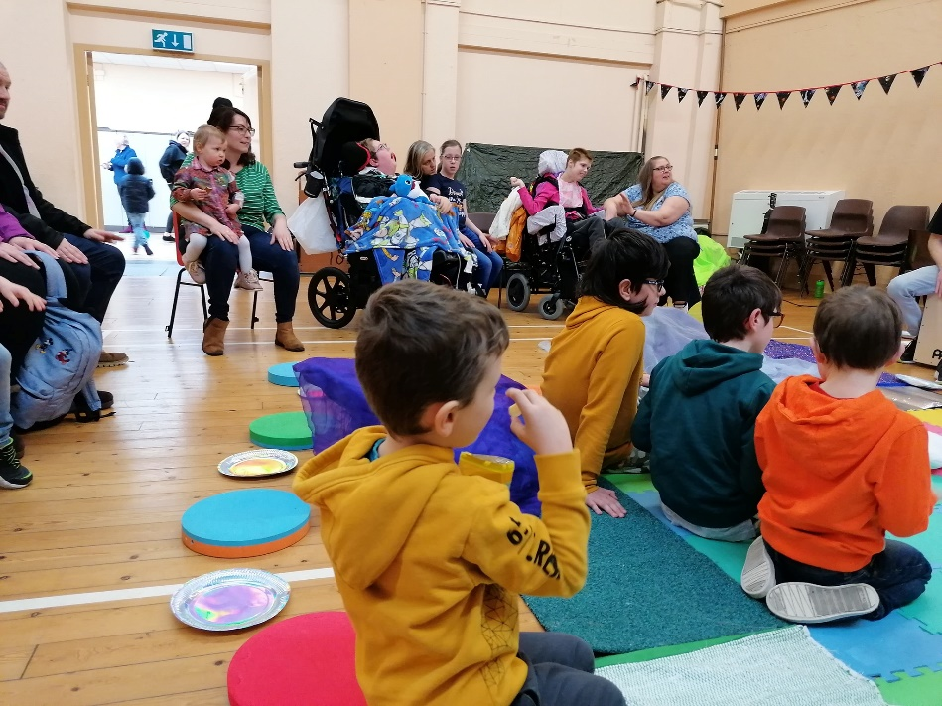

After School Club
Aims and objectives
To re-establish After School Club

What we achieved
After school club started on tentatively with only a few members returning due to the worry of COVID-19 for parents. However, over time, numbers picked up and it was by the end of the year back to pre-COVID 19 numbers with the children having fun and socialising. Children are looking forward to Club re-establishing after summer holidays in the new premises with the gardens attached and there are plans in place to provide Box Fit and gaming club in the near future.

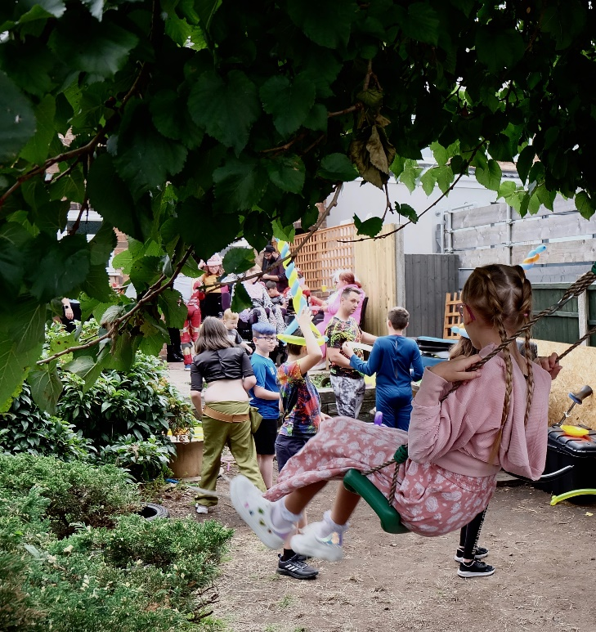
Sensory Garden
Aims and objectives
The Sensory Garden will become an outdoor space for children to play in a safe environment with other children to socialise and have fun.

What we achieved
The plants and trees in the garden are maturing and beginning to look more established. The colours, smells and movement of the plants offer a lovely sensory experience for those who need sensory input. Families are now confident that the space is fully secure, and are able to let their children wander, explore and have fun while they themselves can relax and have a cuppa with other parents.
The garden is used during the day by pre-school children and those home schooled. We also deliver at the weekend by our regular service users. Use of the garden is by booking system to ensure numbers are restricted and to allow cleaning time between guests.

ETHOS
Aim
Our ethos of a happy child making a happy family stand strong and feedback shows us that our services support this theme.

What we have achieved
Given that this summer holidays activities have had to be limited by numbers, it has been extremely successful with 104 children attending, 76 attending more than once and 33 more than five times. We have had some fantastic reviews on our social media:

“We’ve had the most fantastic days this summer, Sam’s favourite session was clay and bead making. Robbie loved circus day. My favourite was den building, it was so much fun but best of all we’ve shared so many days with friends, it’s been a fantastic holiday, so many meets with our friends and lunch dates after sessions. We have made some lovely new friends. Thank you to everyone at Square Peg for all the fantastic sessions. How many sleeps until half term events? “

“My 2 have loved every minute of coming to the Square Peg, it’s made our summer hols so much more enjoyable, they enjoyed all of the sessions and making new friends and I liked having adults to talk to. Thank u everyone for having us and making us welcome.”

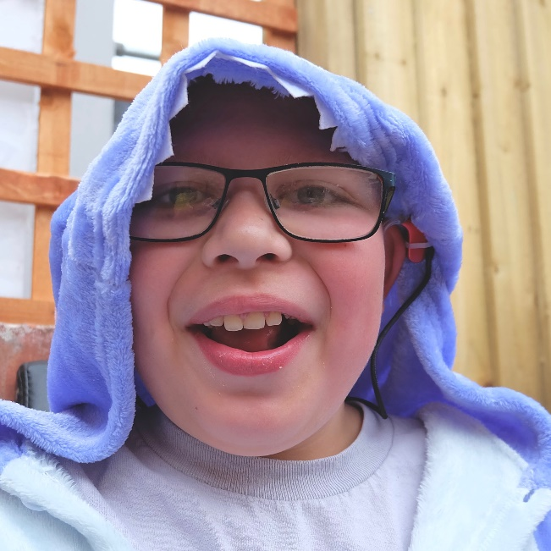
Christmas has always been the best part of the year for us. Our Christmas events are booked many weeks in advance with great anticipation. We understand the importance of doing things differently for the children who attend our events and the Santa visit with grotto is no exception. People enjoy our event as it is entirely designed around the needs of the children and because of that there is no queuing, no crowds, no wrapped and then unwanted gifts (ours are laid out like a shop where the child can select their own) no 3 mins with Santa badgering the child if they “have been a good boy/girl,” Santa is specially selected and trained to get onto the child’s level and take their lead from them. This all creates a magical experience which the adults enjoy just as much as the children. It truly is the most wonderful time of the year!

Now our services are back, the children now have some structure and normality know that club “is on,” stay and play “is on” without the uncertainty of the past year or so. The regularity gives the children confidence and assurance that they have missed recently because of COVID-19. Happy child equals a happy family.

CORE VALUES

Support
Aims
To provide ongoing support to children with additional needs by providing a range of accessible activities. In addition, to provide support to parent/carers on a range of issues
What we achieved
Engagement has increased over the last year with families coming to terms with what is the “new normal.” They have said that they have confidence in our ability to be COVID-19 secure. With the advent of the new premises and plans for new activities, we have taken into account what the children want, we have asked them their opinions and will give them a sense of ownership of the new clubs. The newly established parent/carer advocacy service is popular and has been utilised by The Children's Trust, we are regularly given referrals from its Family Support Workers. Engagement with Stay and Play has returned, in fact we have been introduced to many new families who have heard about us from a range of methods including word of mouth, Child Development Centre and schools.

Belong
Aim
We are keen that participants feel that they are pivotal to the development and delivery of our activities and welcome suggestions to make sure they are getting what they want and to foster a sense of belonging. The children have been central to decisions made regarding the new clubs.
What we achieved
Giving the children the lead on activities gives them a feeling of belonging and ownership. Our Play Leaders adopted this method during the summer holidays and it was great to see then children using their imagination, working together and some taking leadership roles.
Enjoy
Fun is our aim, if the children are having fun, parents are happy and this goes toward our overall purpose and ethos.
Aims
Enjoyment is the aim; enjoyment brings families back time after time and it is the basis of what we do.
What we achieved
With two gardens to explore, the children have been offered different types of fun. They know they can play in either or both, enjoy the spaces and feel free. Parents are safe in the knowledge that there is no way out for the children so they too can relax and enjoy the time. Our seasonal events, Easter, Halloween and Christmas were booked up as soon as the schedules were promoted. The booking system allows a better management of time and a smoother running of events.

Learn
Our delivery takes the form of fun with learning.
Aim
Where we can we add an element of learning from a fun perspective.
What we have achieved
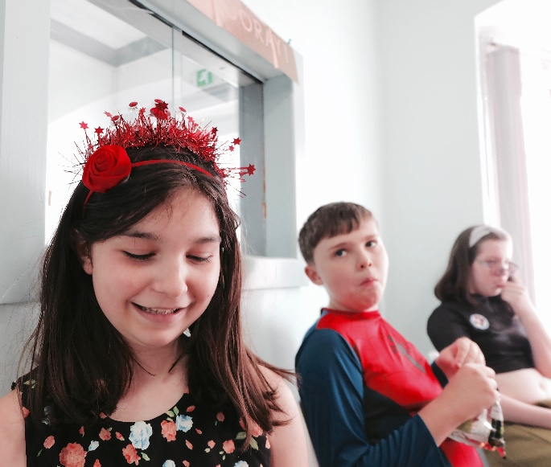
Learning can come in many different forms. Working together to build a den, or learning how to use science to make dry ice. It could be as simple as learning the process of making a pizza or smoothie or even learning how to manage small animals or to walk on stilts. We are keen that children are given the chance to try new things and to teach them how to do something for themselves. Our range of activities this summer alone has given many learning opportunities which the children see as fun.

What we have achieved

IMPACT From a recent survey:
100% of respondents stated our activities has a positive impact on family life
100% of respondents stated that our activities reduced their children’s social isolation
80% of respondents stated that our activities reduced social isolation for parents
80% of respondents stated they feel our activities creates a sense of Community
90% of respondents stated that our activities created inclusive fun
73.3% of respondents stated that our activities give their children a sense of increased self esteem
FUTURE PLANS

2021 has seen a mix of emotions at Square Peg HQ. We have been saddened that we were so limited with numbers allowed into the garden in the early months of the year yet delighted with the progress we have made in other areas. By summer we had been able to increase our numbers of participants, we had taken on new premises, which will be fully functioning by the second week in September. This will give us indoor space of our own allowing us to host more clubs and film nights. The expansion has allowed us the dedicated space to support parents which is important to us to give them the confidence to get the best for their children. The new style garden gives a new facet to play, and certainly has a learning element for sowing, growing, tending and enjoying produce. Two different gardens and two indoor spaces will mean that the organisation can grow and give more opportunities to more children with additional needs.

- We will return to promoting our services to statutory bodies so more families can learn about the work we do
- We will uphold our policies, procedures and training of staff to ensure we are best placed to offer the services to families
- We will continue to canvas opinion from our service users both young and old to ensure we are providing what they want
- We will continue with our efforts to secure corporate funding from local businesses and organisations to make Square Peg Activities Limited more financially secure rather than relying on reactive short-term project fundraising. This will allow us to create more structure and stability and grow organically as an organisation

2021 KEY OBJECTIVES
PURPOSE - continue to provide fun activities for disabled children by encouraging them to make suggestions and taking ownership
ETHOS – ensure that children who attend our services are happy by having great play and learning experiences and at the same time that the parents feel supported.
CORE VALUES – by practicing our purpose and ethos the core values will automatically be met

In our last Annual Report, we vowed to:
“Recruit at least one local business or organisation to become their charity of choice “This has been achieved. Fenix Business Solutions support us with supplying all equipment and services for businesses either free of charge or at cost prices which makes a huge difference to our organisation. Their unswerving commitment to our charity is heart-warming and gives us the confidence to know they are there when we need them.
“To achieve a modest growth in income and funds “Our financial accounts show this has been achieved.
“Introduce a system of client feedback for all our services and activities and use it to improve them “This is still a work in progress although we have adopted the use of Facebook Polls and Survey Monkey which gives us fast accurate results as and when needed.
“Begin a monthly giving subscription system so people can support us financially on a more structured and regular basis” With the uncertainty of how people were affected by COVID-19 we made the decision that this was not the right to time to ask people to make a financial contribution, this has now been shelved until next year.
“Make connections with external organisations to secure learning opportunities to offer in Stay and Play sessions.” We have utilised the services of Play Leaders and engaged services for visiting entertainers which has made a huge difference to Stay and Play 2021

FUNDRAISING
Square Peg Activities Limited is a member of the Fundraising Regulator, its income is generated predominantly by grant and trust funding and our own fundraising events. We do not employ the services of any fundraising agencies or third parties, nor have we fun any direct mail, telephone, door to door fundraising campaigns. Our relationship with our supporters is very important to us and the charity does not wish for our supporters including vulnerable people to feel under any pressure to donate to the charity.
We have a culture of making the most of every opportunity and maximising every penny. In our second year our turnover was £64,394 with a gross profit of £63,557 and an operating profit of £21,200. A shift to a longer term more sustainable approach to income generation is now required so we can reap the benefits of cost efficiencies in the future. This will include an introduction of a charity giving plan and to source alternative and additional Trusts and Foundation grant giving so as not to be reliant on the same funders in the future.
We received no complaints about our fundraising practices in 2020.

WHERE OUR MONEY COMES FROM AND HOW WE SPEND IT
TOTAL INCOME: £64,394
Donations £7,364
Trust and Foundation Funding £57,030

TOTAL EXPENDITURE: £43,193

Reserves Policy
Trustees aim to secure a level of reserves to maintain sufficient unrestricted funds of at least six months running costs to ensure Square Peg Activities Limited remains solvent. This amounts to £1500 based on 2021 output. The charity currently holds reserves of £30,232 unreserved amounts of £18,278 which equates to 10 months running costs.
Charity and Trustees are currently investigating further ways to develop sustainable funding streams. It is the duty of the Trustees to monitor reserves available to be able to fund the activities of the charity and they regularly review the reserves required to meet known and estimated expenditure in furtherance of the charity’s objectives and for its administration.

Restricted Funds
Restricted Funds which are received from Trust or Foundation funders can only be applied to defined activities. Restrictions can either arise because of a condition set by a donor/funder on how income may be applied or because an appeal raises funds for a defined area of concern/activity. Restricted Funds carried forward from 2020 are £1,666 from National Lottery Community Fund for delivering activities

Risk management
The trustees have a duty to identify and review the risks that the charity is exposed to and to ensure appropriate controls are in place to provide reasonable assurance against fraud or error. Key risks to Square Peg Activities have been identified and recorded on the Risk Register, alongside appropriate mitigation plans. The charity will report back to the trustees at all board meetings and keep them informed of any new risks identified. Based on the register, the top three principal risks to the charity have been identified as being:
Governance - Lack of skill in operating good Governance
Lack of Staff – Lack of confidence in sustainability
The charity has considered these risks and has the following mitigating actions in place
Trustees will upskill their knowledge by accessing information from the charity’s commission
Lack of Reserves – Management will determine monthly outgoings then work toward a 6 month reserves policy
We continue our working relationship with Children’s Quarter sharing best practice and participating in jointly run activities.

ADMINISTRATION and REFERENCE
Statement of public benefit
Under the Charities Act 2011, charities are required to demonstrate that their aims are for the public benefit. The two key principles which must be met in this context are, first, that there must be an identifiable benefit or benefits; and, secondly, that the benefit must be to the public, or a section of the public. Charity trustees must ensure that they carry out their charity’s aims for the public benefit, must have regard to the Charity Commission’s guidance, and must report on public benefit in their Annual Report. Square Peg Activities Limited Board of Trustees regularly monitors and reviews the success of the organisation in meeting its key objective of providing appropriate leisure activities for children with disabilities and their families. The trustees confirm, in the light of the guidance, that these aims fully meet the public benefit test and that all the activities of the charity, described in the Trustees’ annual report, are undertaken in pursuit of these aims

Statement of responsibilities of the trustees
The trustees (who are also directors of Square Peg Activities Limited for the purposes of company law) are responsible for preparing the Trustees’ annual report and the financial statements in accordance with applicable law and United Kingdom Accounting Standards (United Kingdom Generally Accepted Accounting Practice)
Company law requires the trustees to prepare financial statements for each financial year which give a true and fair view of the state of affairs of the charitable company and of the incoming resources and application of resources, including the income and expenditure, of the charitable company for that period. In preparing these financial statements, the trustees are required to:
• Select suitable accounting policies and then apply them consistently
• Observe the methods and principles in the Charities SORP
• Make judgments and estimates that are reasonable and prudent
• State whether applicable UK Accounting Standards and statements of recommended practice have been followed, subject to any material departures disclosed and explained in the financial statements
• Prepare the financial statements on the going concern basis unless it is inappropriate to presume that the charity will continue in operation The trustees are responsible for keeping proper accounting records that disclose with reasonable accuracy at any time the financial position of the charitable company and enable them to ensure that the financial statements comply with the Companies Act 2006, the Charities and Trustee Investment (Scotland) Act 2005 and the Charities Accounts (Scotland) Regulations 2006 (as amended).
They are also responsible for safeguarding the assets of the charitable company and group and hence for taking reasonable steps for the prevention and detection of fraud and other irregularities. In so far as the trustees are aware:
• There is no relevant audit information of which the charitable company’s auditors are unaware
• The trustees have taken all steps that they ought to have taken to make themselves aware of any relevant audit information and to establish that the auditors are aware of that information
The Trustees are responsible for the maintenance and integrity of the corporate and financial information included on the charitable company’s website. Legislation in the United Kingdom governing the preparation and dissemination of financial statements may differ from legislation in other jurisdictions. These accounts have been prepared in accordance with the provisions applicable to companies’ subject to the small companies’ regime.

Registered England & Wales charity number: 1185040
Registered Office: 39 Gate Lane Sutton Coldfield B73 5TR
Chief Executive Officer: Ms Lauren Baker
Board of Trustees:
Mrs Sharon Needham - Chair
Ms Lauren Baker
Miss Rhona Davis
Ms Ramandeep Kaur
Mrs Claire Greaves

THANK YOU
Individuals
Sara Jones Kathryn Mann
Michelle Baker Craig Marks
Frank Baker Michael Harrison
Jonathan Jones Jo James
Paul Palin Laura Watts
Claire Palin Nathan McCarthy
Ben Bagri Steve McCarthy
Andy Perks Andy McLaren
Mike Boddice Chris Brown
Joanna Drinkwater

Charities
Children’s Quarter
Chatterbox
Rotary Club Four Oaks

Companies
Sunlight Windows Fenix Business Solutions
AJM Electrical Services Knight Frank
Sentinel Fire & Security Systems Canopy Garden Services
ADS Tesco
Trustees
Sharon Needham
Lauren Baker
Claire Greaves
Rhona Davis
Ramandeep Kaur

GET IN TOUCH
Square Peg Activities Limited 37 Gate Lane Sutton Coldfield B73 5TR
squarepegactivities@outlook.com
0121 824 0508
Facebook: https://www.facebook.com/squarepegcharity

